**Capstone Project 1**



CMU-SE 450

**Architecture Design**

**Version 1.0**

**Date: 27/03/2023**

**LinguaSnap for Travelers**

**Submitted by**

**Dat, Nguyen Thanh**

**Truong, Vu Dinh**

**Long, Pham Ba Hoang**

**Kha, Nguyen Ngoc**

**Approved by Nguyen Duc Man**

**Capstone Project 1- Mentor:**

Name Signature Date

**INTERNATIONAL SCHOOL OF DUY TAN UNIVERSITY**

**Project Information**

|  |  |  |  |
| --- | --- | --- | --- |
| **Project acronym** | LiS | | |
| **Project Title** | LinguaSnap for Travelers | | |
| **Start Date** | 25 Feb 2023 | **End Date** | 31 May 2023 |
| **Lead Institution** | International School, Duy Tan University | | |
| **Project Mentor** | Man, Nguyen Duc, Ph.D. | | |
| **Scrum master / Project Leader & contact details** | Nguyen Thanh Dat  Email: ntdat1232001@gmail.com  Tel: 0972.530.969  Student ID: 25211217197 | | |
| **Partner Organization** |  | | |
| **Project Web URL** |  | | |
| **Team members** | Name | Email | Tel |
| 25211217197 | Dat, Nguyen Thanh | ntdat1232001@gmail.com | 0972530969 |
| 25211201774 | Long, Pham Ba Hoang | longphambahoang@gmail.com | 0793310221 |
| 25211217275 | Truong ,Vu Dinh | jonnyvu2210@gmail.com | 0905223611 |
| 25211210026 | Kha, Nguyen Ngoc | winkha14567@gmail.com | 0945721427 |

**Architecture Document**

|  |  |  |  |
| --- | --- | --- | --- |
| **Document Title** | Architecture Design Document |  |  |
| **Reporting Period** |  |  |  |
| **Author(s)** | Truong, Vu Dinh | |  |
| **Team Information** | **Name** | **Role** |  |
| Dat, Nguyen Thanh | Leader |  |
| Truong ,Vu Dinh | Member |  |
| Kha, Nguyen Ngoc | Member |  |
| Long, Pham Ba Hoang | Member |  |
| **Date** | 27-03-2023 | **Filename** | C1SE.05_LiS_Architecture  Design_V1.0.docx |
| **Access** | Project and CMU Program | |  |

|  |  |  |
| --- | --- | --- |
| Document History | | |
| **Version** | **Date** | **Comments** |
| V1.0 | 27/03/2023 | Create Architecture Document |

**Document Approvals**

The following signatures are required for approval of this document.

|  |  |  |
| --- | --- | --- |
| **Document Approval** | | |
| Man, Nguyen Duc(Ph.D)  Mentor |  | Date |
| Dat, Nguyen Thanh  Scrum master, DevTeam |  | Date |
| Truong, Vu Dinh  Product Owner, DevTeam |  | Date |
| Long, Pham Ba Hoang  DevTeam |  | Date |
| Kha, Nguyen Ngoc  DevTeam |  | Date |

**TABLE OF CONTENTS**

1. Introduction 8

**1.1 Project overview 8**

**1.2 Purpose 8**

2. Architecture drivers 9

**2.1 Business constraints 9**

**2.2 Technical constraints 9**

**2.3 Functional requirement 9**

**2.4 Quality attributes 9**

**2.4.1 Security 9**

**2.4.2 Performance 10**

**2.4.3 Usability 12**

**2.4.4 Modifiability 14**

3. Architecture overview 14

**3.1 System context 15**

**3.2 Component and connector 16**

**3.3 Sequence diagram 18**

**3.3.1 Login 19**

**3.3.2 Sign up 19**

**3.3.3 Spell check 20**

**3.3.4 Text Recognition 21**

**3.3.5 Translate 21**

**3.3.6 Dictionary 22**

**3.4 Module view 23**

**3.5 Allocation view 24**

4. ATAM 26

**4.1 Present the ATAM 26**

**4.2 Present the business Drivers 26**

**4.3 Present the Architecture 27**

**4.4 Identify the Architecture approaches 27**

**4.6 Analyze the Architectural approaches 27**

**4.7 Brainstorm and prioritize scenarios 28**

**4.8 Re-analyze the architectural approaches 28**

**4.9 Present the results 28**

# 

# Introduction

## Project overview

To build an application with full features for users to translate and search after translation (LinguaSnap for Travelers). Users can translate from image scan to search by image or search for content after detecting the language from the image. Users can review their usage history content.

## Purpose

This specification covers following:

* Brief specification of the project, high level requirement.
* Detail quality attribution.
* System context, sequence diagrams.
* Architecture presented by various view types: Component and Connect, Module view and Allocation view.

## Business driver

Business Problems:

* Until now, the only way to translate was for 'interpreters' to study multiple languages and try to translate and bridge language boundaries for different purposes.
* When traveling or studying, people need an application that can translate and search in the most accurate way, helping people to quickly solve the necessary problem.

Business Need:

* A application that can translate from other languages and search based on the results after translation
* The application allows scanning from images to text to find information, or search right from images to help us select text, search for favorite content in a smart way....
* No need for users to finish copying and searching on other websites, this will cause time and errors in the process of copying and uploading to other websites.

# Architecture drivers

## 2.1 Business constraints

* Sources: 4 people.
* Project was started on: 25/02/2023.
* Project will be ended on: 31/05/2023.
* Project will be finished in 64 days (512 hours).
* Cost: $2248.

## 2.2 Technical constraints

Technical to develop:

* Programming Language: Java.
* Frameworks / Libraries: API of Google Cloud, Google ML Kit.
* Database Management System: Firebase

Environment:

* App environment: Android

## 2.3 Functional requirement

References to Product Backlog specification of ProductBacklogV1.1.docx

## 2.4 Quality attributes

#### 2.4.1 Security

|  |  |
| --- | --- |
| Scenario: when the users forgot their password, when will enter their email correctly to recover the code to update your password again. | |
| Type | Security |
| Stimulus | Forgot password |
| Source of stimulus | User |
| Environment | In runtime |
| Artifact stimulated | Application |
| Response | Confirmation code sent to your email |
| Response measure | If they do not enter the correct code, they won't get permission to set a new password. |

|  |  |
| --- | --- |
| Scenario: When a user registers, their password will be encrypted via firebase authentication before being saved to firebase | |
| Type | Security |
| Stimulus | Register |
| Source of stimulus | User |
| Environment | In runtime |
| Artifact stimulated | System |
| Response | Encrypt password |
| Response measure | encrypted via firebase authentication |

#### 2.4.2 Performance

|  |  |
| --- | --- |
| Scenario: Users after entering input text and pressing translate, the results will be returned in less than 3s | |
| Type | Performance |
| Stimulus | Translate text |
| Source of stimulus | User |
| Environment | In runtime |
| Artifact stimulated | Application |
| Response | Translation and response time after translation |
| Response measure | less than 3 seconds |

|  |  |
| --- | --- |
| Scenario: When the users click on the history to search for information about what they have translated, the system will respond in less than 5 seconds. | |
| Type | Performance |
| Stimulus | Respond list history of user |
| Source of stimulus | User |
| Environment | In runtime |
| Artifact stimulated | Application |
| Response | Verify user and response their list history |
| Response measure | less than 5 seconds |

|  |  |
| --- | --- |
| Scenario: When the user enters the incorrect grammar of that language, the system will suggest the correct format of that language for the user to check. | |
| Type | Performance |
| Stimulus | Respond format result from enter text of users |
| Source of stimulus | User |
| Environment | In runtime and stable network connection |
| Artifact stimulated | Application |
| Response | A suggested text |
| Response measure | within 5 seconds |

#### 2.4.3 Usability

|  |  |
| --- | --- |
| Scenario: Users can login on multiple devices at the same time. The data is still updated continuously and accurately thanks to the real-time database. | |
| Type | Usability |
| Stimulus | Allows users to use multiple devices at the same time with 1 account |
| Source of stimulus | User |
| Environment | In runtime |
| Artifact stimulated | Application |
| Response | Allows access with multiple devices |
| Response measure | both ways |

|  |  |
| --- | --- |
| Scenario: After the translation is complete, users do not need to copy the translation to search. Users can search directly at the app by pressing the search button. | |
| Type | Usability |
| Stimulus | Search for translated in app |
| Source of stimulus | user |
| Environment | The system |
| Artifact stimulated | Application |
| Response | Can search the translated in app |
| Response measure | Instantly |

|  |  |
| --- | --- |
| Scenario: The system will check if the user has logged in before, if the user is logged in, the system will redirect the user to the transaction page. | |
| Type | Usability |
| Stimulus | Check session |
| Source of stimulus | User |
| Environment | In runtime |
| Artifact stimulated | The system |
| Response | Redirect the user to the transaction page |
| Response measure | Redirect the user to the transaction page if use logged in |

#### 2.4.4 Modifiability

|  |  |
| --- | --- |
| Scenario: A product manager who wants to develop additional features can search for images, search for information after translating on the app, and then save these data on this app's own search history. | |
| Type | Modifiability |
| Stimulus | Develop more features to search images, search text in the app and save search history on the app |
| Source of stimulus | A product manager |
| Environment | The next version |
| Artifact stimulated | The system |
| Response | Allows for an expansion |
| Response measure | 4 person months of effort without affecting existing functions |

# Architecture overview

This section shows the diagrams which bounds our target system and describes the architecture and interaction between components

## 3.1 System context

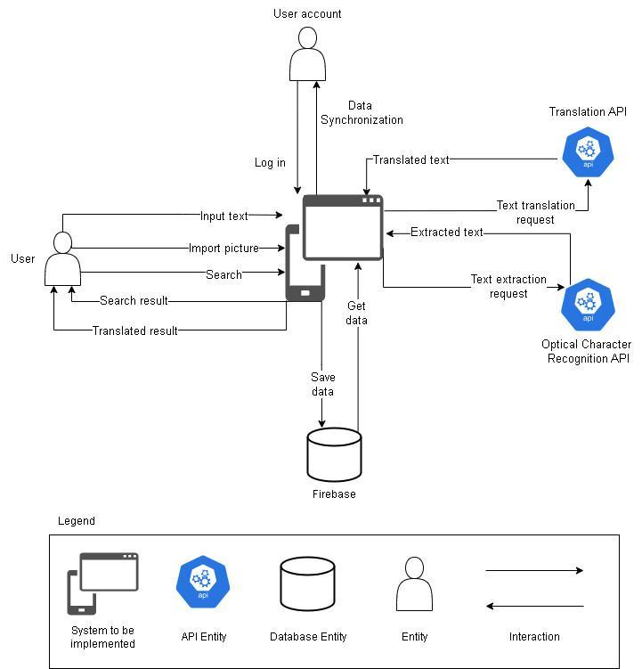

**Figure 1: System Context Overview**

**User:**

* Request Login/Logout to the system, System check information and response
* Request to register a new account, system check and save account if it isn't in the database.
* Request to change password, if account has logged in.
* Request to view list history, the system will respond to the list of history.
* Request to view list bookmark, the system will respond to the list of bookmarks.
* Request to search text, the system will respond to translation results.

**Firebase System:**

* Request Login/Logout to the system, System check information and response
* Enter register new account, System saves account.
* Request change password, System check information and response if it is successful.
* Request to view list history, System response view tour.
* Request to view list bookmark, system response tour detail.

**API System:**

* Request to translate text, system check information and response translation results.
* Request to text extraction, system check information and response extracted text.
* Request to crop image, system check the image and response by text.

## 3.2 Component and connector

We mainly used a C&C view to argue and reason about architectural properties, quality attribute requirements, and functional requirements that the system must add here.

This view type partitions the system into components that have some runtime presence such as processes, objects, data stores, and connectors or that represent pathways of communication such as data flows and access to shared storage.

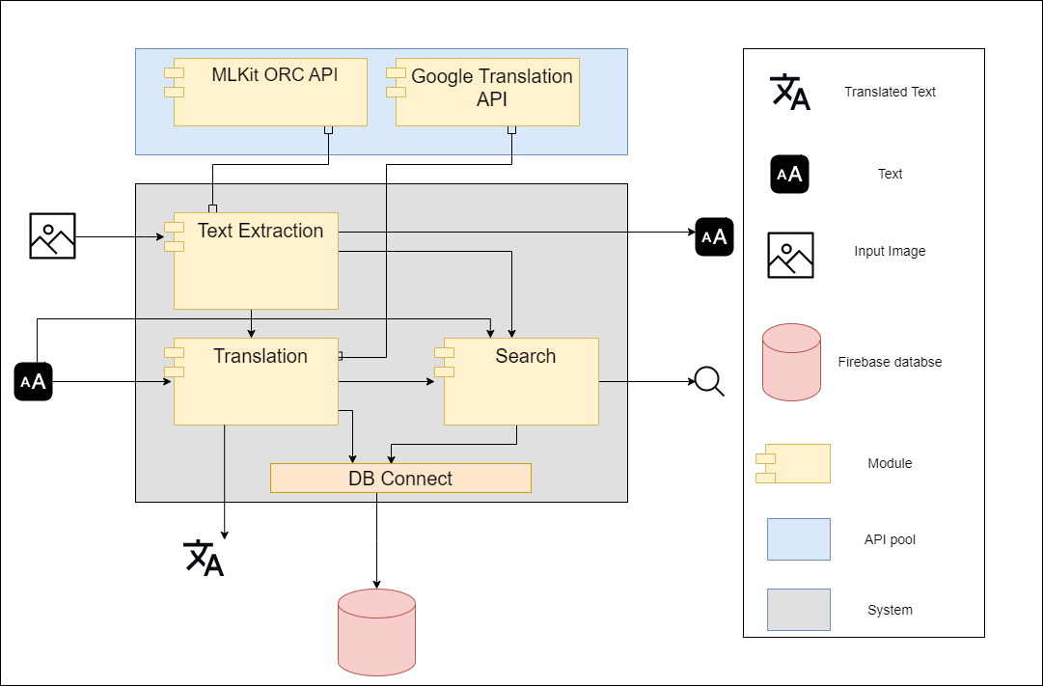

**Figure 2: C&C View (User)**

**Prose**

Users will access the system by logging in to the application. After approval, the Home page will be displayed. The users will be able to see all the features the system provides on the interface and use them correctly.

|  |  |
| --- | --- |
| **Element** | **Responsibilities** |
| Text Extraction | Users can provide images by importing or taking pictures for the app to recognize. They will then display the texts extracted from the images. |
| Translation | Users can either type the text manually or use the Text Extraction function to capture the text directly. The application swiftly presents a translated version in a language of their choice. |
| Search | Users can search the texts extracted or translated on Google, with the browser of their choice. Users can also search for images on the internet that resemble the ones they took or imported. |
| Google translation API | Provides essential functionalities for seamless language translation. Its responsibilities include leveraging Google's powerful translation engine, handling input text, and delivering accurate translations in a variety of languages. |
| MLKit OCR API | Leverages machine learning capabilities to perform accurate Optical Character Recognition (OCR) on captured images or text input. |

## 3.3 Sequence diagram

Sequence diagram is used to display the sequence of activities. Sequence diagrams show the workflow from a start point to the finish point detailing the many decision paths that exist in the progression of events contained in the activity.

### **3.3.1 Login**

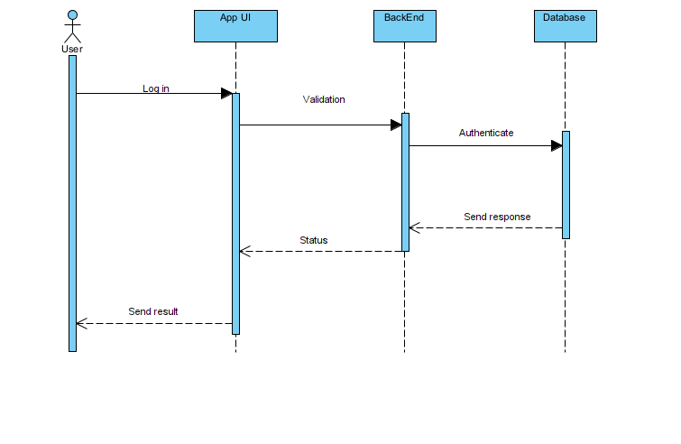

**Description:**

To use the LinguaSnap application, the user must first log in with a username and password. Our system receives the request, authenticates and returns the login status.

If login successfully, users can use all functions of the system in their permission. Otherwise, their access will be denied.

### **3.3.2 Sign up**

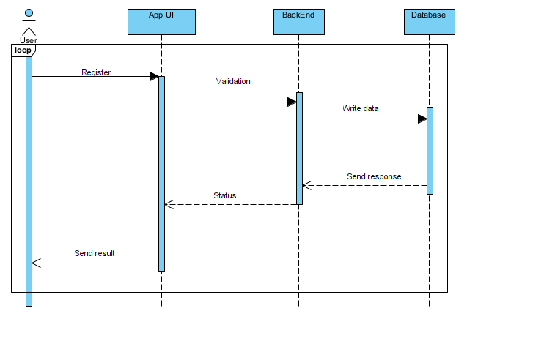

**Description:**

To login to the system, users have to register first.

Users are allowed to register a new account, to do that they create a new account with email and password.

### **3.3.3 Spell check**

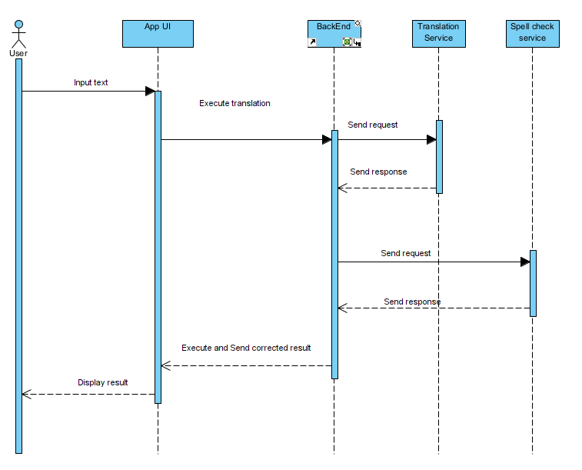

**Description:**

To check your grammar when you input some text incorrectly.

The system will send text to the translation service to get a spelling mistake, then we will send it to the spell check service to fix the mistake and get it. After that we will choose the best correct check and suggest that text into screen.

### **3.3.4 Text Recognition**

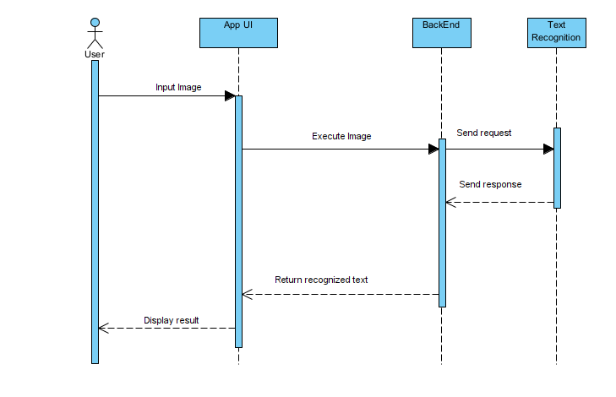

**Description:**

To be able to recognize text, the user inputs an image.

The System will execute the image and send the text results to the screen.

### **3.3.5 Translate**

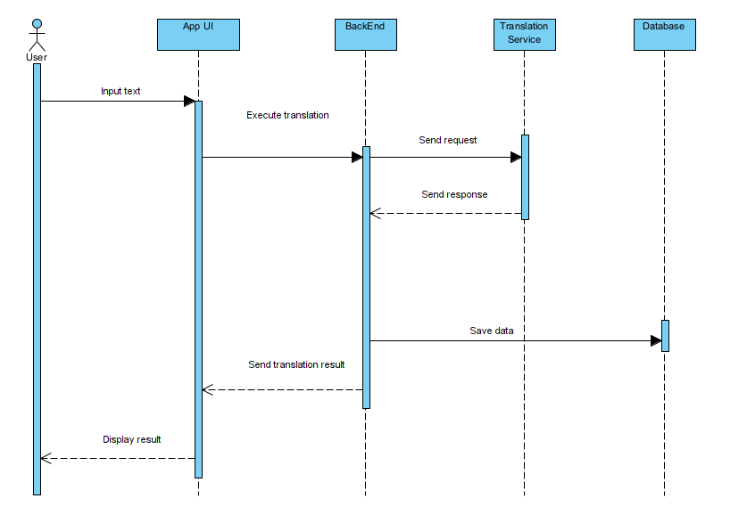

**Description:**

When the users input text, the system uses translation service to analyze the text and provide a translation in the selected language.

The translation can be displayed directly on the page and will be saved in history.

### **3.3.6 Dictionary**

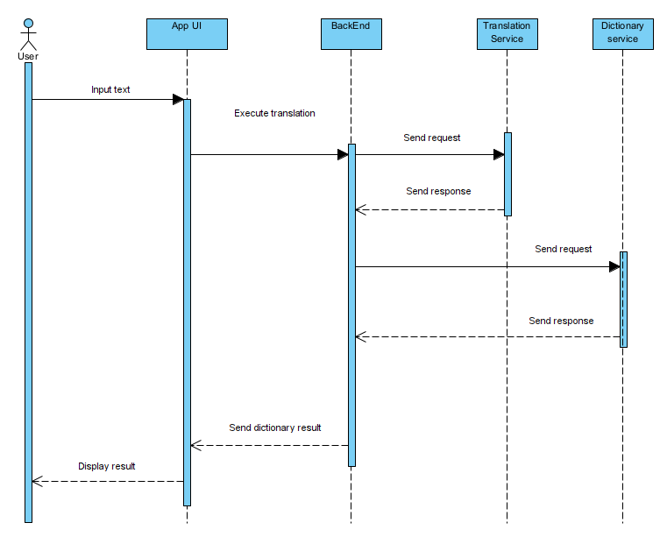

**Description:**

When the user input text, the system uses translation service to get a spelling mistake, then we will send it to the dictionary to get the meaning of the text. Then we will get results and show them on screen.

The translation can be displayed directly on the page.

## 3.4 Module view

**Figure 3: Module view**

**Prose**

|  |  |
| --- | --- |
| **Element** | **Responsibilities** |
| App View | The application package contains interface modules for the users to use the functionality of the app |
| Firebase Authentication | The users must login to the app through firebase authentication. Only then the user can use the functions provided by the system |
| **Controller** | Accepts input and converts it to commands for the model or view |
| **Model** | Object data modules connected to the database or API for transmission to the system interface |
| **Firebase Database** | Contains all data about the user |

**Description:**

The system includes app view, services and models. After users interact with the UI. Data will be requested from the corresponding service, then will be directed to the model. Data to be responded to will be displayed on UI**.**

## 3.5 Allocation view

The allocation view models the run-time architecture of a system. It shows the configuration of the hardware elements when the system is deployed.

**Figure 4: Allocation View**

**Prose**

|  |  |
| --- | --- |
| **Element** | **Responsibilities** |
| Phone | The users use this device to install and use the app. |
| **Internet** | Stop or mitigate unauthorized access to private networks connected to the Internet, especially intranets |
| Firebase Authentication | The app uses it to authentication users. |
| **APK File** | Allows users to install the system |

**Description**

The system is deployed on mobile environment. They interact with the server through API to read and write data from Firebase. In addition, the system interacts with Firebase Authentication to authenticate users.

# ATAM

## Present the ATAM

* Overall evaluation of system architecture documents, system designs on 3 views: static view, dynamic view, and physical view based on ATAM 9 Steps method.
* Expect to achieve an accurate and objective evaluation of the architectural document. From there, the project team assesses the ability to complete the project and achieve the Architecture Drivers.

## Present the business Drivers

* The content on the document presented about the following:

Who are the business drivers.

* Business problems and goals for the system are presented by the Project decision makers.
* System’s features.
* System’s requirements.
* Project constraints.
  + Project scope.

## 4.3 Present the Architecture

* Current Architecture state: The design is systematically overviewed on all 3 views: allocation view, module view and component and connector view.
* Expected Architecture state: The architecture is easy to understand, easy to read, full of content, clear and responsive to the constraints and Quality Attributes of the system.
* Impact of following project constraints in the architecture:
  + Time / Deadline: Project will be finished in 64 days (512 hours)
  + Cost / Available resources: 4 people with cost $2248
  + Complexity of the problem: high
  + Quality expectations: Meet the constraints and 5 Quality Attributes described above include: Security, Performance, Usability and Modifiability.

## 4.4 Identify the Architecture approaches

* Architecture pattern: Service-oriented architecture (SOA)
* In SOA, services use protocols that describe how they pass and parse messages using description metadata. This metadata describes both the functional characteristics of the service and quality-of-service characteristics. Service-oriented architecture aims to allow users to combine large chunks of functionality to form applications which are built purely from existing services and combining them in an ad hoc manner. A service presents a simple interface to the requester that abstracts away the underlying complexity acting as a black box. Further users can also access these independent services without any knowledge of their internal implementation
* The architectural blueprints are broken down into sections and interact with the services.

## Analyze the Architectural approaches

|  |  |
| --- | --- |
|  | Evaluate |
| Tradeoffs | + With a service bus system, the performance level is enhanced and the trade-off in system security decreases  + Ease of use pays off with system performance. Meeting good performance reduces ease of use and vice versa |
| Sensitivity points | + Dependence on the services of external systems  + Depends quite a lot on the network system and the data transmission speed of the services.  + No data backup solution yet |
| Risk and non-risk scenarios | + When security is threatened, hackers attack services, security can be affected.  + Network problem occurred.  + A service is dead. |

## 4.7 Brainstorm and prioritize scenarios

* Rank priority based on the constraints and attributes(descending):
  + Performance
  + Security
  + Usability
  + Modifiability

## 4.8 Re-analyze the architectural approaches

* Validate with the system architect to discover and achieve with the system design.

## 4.9 Present the results

* Based on the above reviews:
  + The system can accommodate a number of Quality Attributes and constraints given.
  + However, some systemic risks will appear affecting the system and the Quality Attributes will be in order of priority.

References:

|  |  |  |
| --- | --- | --- |
| **No.** | **References** | **Document Information** |
| 1 | Design standards,  Document standards | https://www.softwarearchitecturebook.com/svn/main/slides/ppt/26_Standards.ppt |
| https://standards.ieee.org/standard/1471-2000.html |
| https://ieeexplore.ieee.org/document/917550 |
| 2 | Patterns | https://en.wikipedia.org/wiki/Architectural_pattern |
| 3. | Evaluation standards | https://www.iso.org/obp/ui/#iso:std:iso-iec-ieee:42030:ed-1:v1:en |
| https://gabrielfs7.github.io/software-architecture/2019/10/18/atam-analyze-evaluate-architecture/ |